Linux Commands

- cd – change directory
- ls – list
- pwd – view current working directory
- sudo su – got to root
- touch – create a text file
- nano – a text editor
- vi – a text editor
- cp – copy files
- mv – move files
- locate – get the absolute path of files
- rm – remove files
- mkdir – create a directory
- rmdir – remove a directory
- man – see the manual of commands
- echo – print something on the terminal
- passwd – change passwords
- chmod – change user permissions (r=read, w=write, x=execute) or (777)
- adduser – adds a new user
- su – switch user
- sudo – super user privileges
- ifconfig – configure a network interface
- iwconfig – configure a wireless network interface
- ping – send requests to network hosts
- arp – shows the ip address and the mac address it’s associated with
- netstat – shows network statistics (-ano = shows only the active connections)
- route – shows and manipulate the routing table
- whoami – see who you are on the system
- whereis – find a location
- cat – output
- > - replace
- >> - append
- gedit – text editor
- 2>> - append errors
- services – manipulate services (start, stop)
- python2 -m SimpleHTTPServer 8090 – host your linux in a web server
- systemctl – manipulate services when system boot up (enable, disable)
- apt-get install - get tools
- && - run two commands (sudo apt-get update && sudo apt-get upgrade)
- git clone – download packages from github
- grep – narrow down results (-n = number of the line)
- cut – narrow down results(-d = delimiter [what we are cutting on]) (-f = filed)
- | - add an additional command
- tr – narrow down results (-d = delimiter)
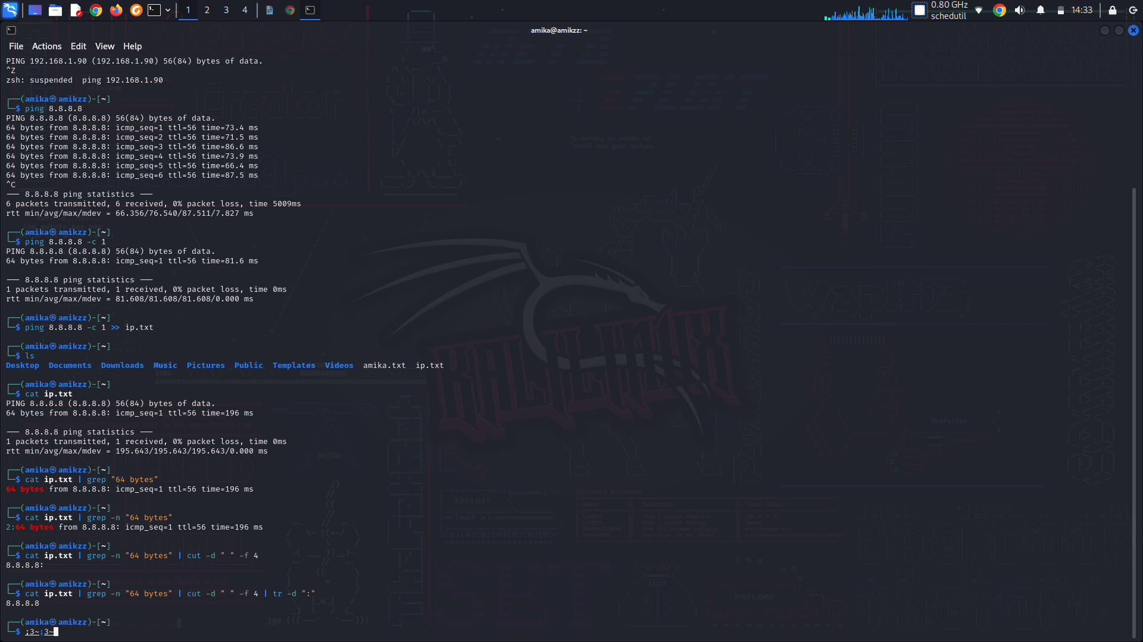
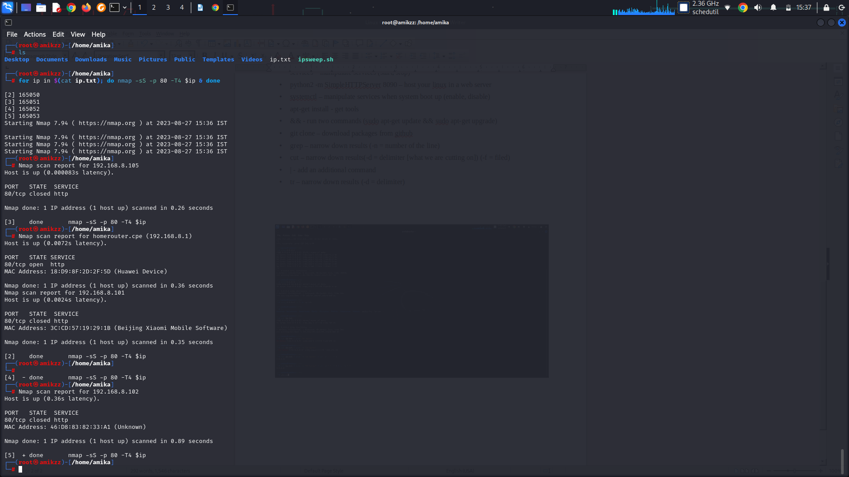
Scripting

